The Morgan County Humane Society is designated as a (501) (c)(3 non-profit organization established to benefit the residents of Morgan County, Alabama. Our shelter, on Gum Springs Cut-Off Road in Hartselle, is located on 8 acres centralized in rural Morgan County.
Volunteer to help our friends!
You can join us in helping orphaned, injured, homeless and helpless animals of Morgan County. Our volunteers and members are instrumental by: fostering animals, nurturing critters and participating in fundraising events. As a licensed and certified wildlife and animal rescue, we are able to rehabilitate and rehome livestock, rehabilitate and release sick, injured, or orphaned wildlife as well as domesticated pets. Our main focus is to help ALL animals- great and small- which are unable to be self-sufficient or care for themselves.
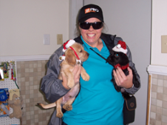
Precious & Major
Forever Homes
The Morgan County Humane
Society Mission Statement
Our goal is to provide a shelter which is a suitable environment for animals-both domestic and wild. We strive to:
- Prevent cruelty, neglect and abuse to domestic, wild and rescued animals.
- Educate the public about low-cost spay/neuter programs to reduce the number of unplanned and unwanted animals in our county.
- Provide a partnership for adoption of animals with local municipal animal control organizations.
- Provide services in compliance with the Alabama Humane Federation for housing, care and adoption of companion animals.

I would like to foster:
(Check all that apply)
Cats: ____ Kittens: _______
Dogs: ____ Puppies: ______
Horses: ___ Livestock: _____
Wildlife: _____
If there is wildlife animal you DO NOT wish to foster, please specify: _________________

If you would like to become a member/volunteer, please complete:
Date: ___________________
Name: ___________________
Address: _________________
_________________________
City: _____________________
State: ____ Zip Code: _______
Home Phone: (____) ________
Cell Phone: (_____) _________
Email address: _________________________

I would like to Volunteer for:

Fundraising Events: _________
Landscaping: ______________
Maintenance: _____________
Shelter Clean-Up: __________
Computer/Admin: __________
Monetary: ________________

Check All That Apply
________ I would like to become a member of Morgan County Humane Society. I would like to receive current information in the form of e-newsletters, notices of meetings, workshops, and fund-raising events. ($30 membership fee)

_________ I would like to become a volunteer for the Morgan County Humane Society.

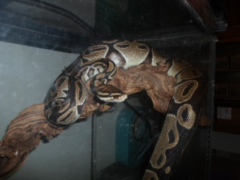

RESOURCES FOR ANIMAL SERVICES
Animal Friends Humane Society provides low-cost spay/neuter programs.
256-351-2347

Decatur Animal Services provides animal control for the Decatur City Limits and an adoption shelter.
256-341-4790

Morgan County Animal Control provides animal control for Morgan County and an adoption shelter.
256-773-2934

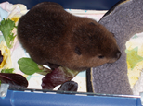

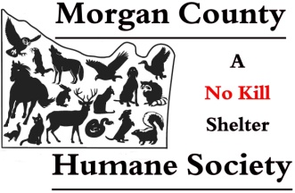
86 Gum Springs Cut-Off Road
Hartselle, AL 35640
256-773-7222
mchs@hughes.net
Robyn Purdy, Director

Please visit us on: Our Website: www.morgancountyhumanesociety.net; Facebook at www.facebook.com/MorganCoHS, or follow us on Twitter @MorCoHumaneSoc.
A 501(c) (3) public non-profit org.

